8 PROMETHEUS GRAFANA

- PROMETHEUS INTRODUCTION
- Before Prometheus or no monitoring tool
- Before Prometheus and modern tools, monitoring was mostly manual, reactive, and painful
- Manual Server Checks (Very Old Days)
- Admins used to : SSH into servers, Run commands like : top, free -m, df -h, uptime, ps -ef, netstat -tulnp
- Problems : Only current state, no history, Had to log in after issue happened
  - Not scalable (10 servers ok, 100+ impossible)

- Log-Based Monitoring : Monitoring = reading logs
- Admins checked : /var/log/syslog, /var/log/messages, Application logs
- Web server logs (Apache/Nginx)
- Problems : Logs are unstructured, Hard to find root cause, No real-time alerting, No metrics (CPU %, memory trends)

- Basic Shell Scripts + Cron Jobs :
- People wrote scripts like:
if [ $(free | awk '/Mem/ {print $3/$2 * 100}') -gt 80 ]; then
echo "High Memory Usage" | mail admin@example.com
fi
- Problems : Very fragile, Hard to maintain, No visualization, One script per check.

- Traditional Monitoring Tools (Pre-Prometheus Era) : Before Prometheus, tools like:
Tool | Type
Nagios | Host/service checks
Zabbix | Agent-based
Cacti | Graphing
Munin | Graph-based
Icinga | Nagios-based

- How they worked : Mostly PUSH-based, Required agents, Config-heavy, Hard to scale for cloud/microservices.

- Alerts Based on Downtime Only :
- Monitoring meant : “Is server UP or DOWN?”, “Is HTTP 200 or not?”
- No insight into : Latency, Error rates, Resource saturation, Future failures

- Life Without Monitoring Tools : If no monitoring at all, teams relied on:
- Users complain first : “Website is slow”, “App is not loading”, “Payment failed”
- This is called : User-reported monitoring (worst kind)
- Result : Reactive firefighting, Long downtime, No SLA/SLO tracking

- What Changed With Prometheus
- Prometheus solved modern problems:
Old Way | Prometheus Way
Manual checks | Automated scraping
No history | Time-series data
SSH per server | Centralized view
No alert logic | Smart alert rules
Static servers | Dynamic Kubernetes

- Why Old Tools Failed for Cloud & Kubernetes : Old tools assumed : Static Ips, Long-living servers
Few services
- Modern world : Containers start/stop, Pods change Ips, Auto-scaling, Microservices
- Prometheus introduced : Service discovery, Label-based metrics, Pull model, Cloud-native monitoring

- “Before Prometheus, monitoring was mostly manual, log-based, or done using traditional tools like Nagios and Zabbix. These methods lacked scalability, real-time metrics, and cloud-native support, making them unsuitable for modern microservices and Kubernetes environments.”

- After Prometheus
- Prometheus born in age of dynamic infrastructure and grouped up as very effective monitoring system to today’s dynamic infrastructure.
- Monitoring and Alerting on monitoring escalation is very necessary in dynamic, cloud native Micro – Services Infrastructure.
- In absence of a good monitoring system, you have to pay high maintenance and operational cost

- PROMETHEUS
- What is Monitoring Tool ?
- A monitoring tool is a software system that continuously observes, collects, and analyzes data from IT systems to ensure they are healthy, available, and performing well.
- Monitoring tool = System health watcher

- A monitoring tool tracks :
  - Infrastructure : CPU usage, Memory usage, Disk space, Network traffic, Server uptime
  - Applications : Response time, Error rate, Request count, Application availability
  - Containers & Cloud : Docker containers, Kubernetes pods & nodes, Cloud VMs (Azure, AWS, GCP)

- Why to Monitor
  - Without monitoring : No idea when or why failures happen, No performance trends, No alerting, Problems are found only after users complain,
  - With monitoring : Detect issues before downtime, Get real-time alerts, Analyze past incidents, Improve system reliability

- Core Functions of a Monitoring Tool : Every monitoring tool does these things:
- Data Collection : Collect metrics, logs, or traces
- Storage : Store data for analysis & history.
- Visualization : Dashboards & graphs
- Alerting : Notify when thresholds are crossed
- Analysis : Find root cause & trends

- What is Prometheus ?
- Prometheus is an open-source monitoring and alerting tool used to collect, store, and query metrics from applications, servers, containers, and cloud resources.
- It was originally developed by SoundCloud
- Now part of CNCF (Cloud Native Computing Foundation)
- Widely used with Docker, Kubernetes, Azure, AWS

- Prometheus = Metrics Monitoring System

- Usage of Prometheus :
- Reason of learning Prometheus is Dynamic infrastructure
- Dynamic infra : Static Infra
- Virtualization
- Containers
- Container Orchestration
- Cloud computing
- Cloud computing is dynamic infra
- To monitor that dynamic infra , Prometheus is required.

- Monitor CPU, memory, disk, network
- Monitor applications & microservices
- Monitor Docker containers & Kubernetes pods
- Generate alerts when something goes wrong
- Perform capacity planning
- Troubleshoot performance issues

- Prometheus built-in labels Core Concept
- Target (WHAT Prometheus Scrapes)
- A target is any endpoint that exposes metrics and can be scraped by Prometheus.
- Prometheus pulls metrics from targets
- Usually a URL ending with /metrics
- Example : http://192.168.1.10:9100/metrics

- Instance (FROM WHERE exactly)
- An instance is a single, unique target address.
- Defined by : <host>:<port>
- If two servers run the same service, each one is a different instance
- Example : instance="192.168.1.10:9100"

- Job (WHO / ROLE of targets)
- A job is a logical group of one or more instances that perform the same function.
- Used for grouping and identification
- Example : job="node_exporter"

- Relationship Between Target, Instance, and Job
  - Think of it like this
Job
└── Instance
└── Target
- One word :
  - Job → node_exporter, Role (Web servers, DB servers)
  - Instances → each IP:PORT, One server/container
  - Targets → actual scrape endpoints, Metrics endpoint

- One Line :
- Target: “An endpoint exposing metrics for Prometheus to scrape.”
- Instance: “A single target identified by host and port.”
- Job: “A logical group of similar instances.”

- Prometheus Terminology

- Monitoring : Monitoring is a systematic process of collecting and recording the activities taking place in a target project, then using that recorded values to check if target reaching their objective or not.

- Alert : It is the outcome of alerting rule in Prometheus
An alert is triggered when a condition is met.
It sent from Prometheus to Alert Manager
Example : CPU > 80% for 5 minutes

- Alert Rule : A rule that defines when an alert fires.
Example : - alert: HighCPUUsage
expr: node_cpu_seconds_total > 80

- Alertmanager : Alert manager handles alerts and sends notifications.
Alert manager takes in alert from Prometheus server.
Do the process on collected data and then send notification as per defined process
Supports : Email, Slack, PagerDuty

- Metric : A metric is a numerical measurement collected over time.
Examples : CPU usage, Memory usage, HTTP request count

- Time Series : A time series is a metric with a timestamp and labels.
Format: metric_name{label1="value1"} timestamp value
Example : node_cpu_seconds_total{cpu="0", mode="idle"}

- Labels : Labels are key–value pairs attached to metrics to identify them.
Labels make metrics flexible and powerful
Example : instance="192.168.1.10:9100"
job="node_exporter"

- Target : A target is an endpoint Prometheus scrapes metrics from.
Example : http://192.168.1.10:9100/metrics

- Scraping : Scraping is the process where Prometheus pulls metrics from targets.
Happens at fixed intervals (scrape_interval)

- Job : A job is a group of targets performing the same role.
Example : job="web_servers"

- Exporter : An exporter is a service that exposes metrics in Prometheus format.
Examples : Node Exporter, MySQL Exporter, Blackbox Exporter

- Sample : A sample is a single data point. (value, timestamp)

- TSDB (Time Series Database) : Prometheus stores data in a local time-series database.
Optimized for : Fast writes, Fast reads, Time-based queries

- PromQL : PromQL (Prometheus Query Language) is used to query metrics.
Example : rate(http_requests_total[5m])

- Counter : A counter is a metric that : Only increases, Resets on restart
Example : http_requests_total

- Gauge : A gauge represents a value that : Can increase or decrease
Example : node_memory_available_bytes

- Histogram : Samples observations, Groups them into buckets
Used for : Request duration, Response size

- Summary : Calculates quantiles (p90, p95), Done on client side
Used for : Latency measurement

- Service Discovery : Prometheus automatically finds targets.
Examples : Kubernetes, EC2, Azure VMs

- Recording Rule : Precomputes expensive queries, Stores result as a new metric
Improves performance

- Instance : An instance is a single target.
Example : instance="server1:9100"

- “Prometheus collects metrics as time-series data, identified by labels, scraped from targets, queried using PromQL, and used for monitoring and alerting.”

- Components of Prometheus
- Prometheus Architecture has 5 main components :
- Prometheus Server : Core component
- Retrieval it will retrieve the metrics from the instance, targets and jobs
- This will store in the metrics in the storage in the TSDB – Time Series DB, to store the custom metrics or metrics Provides PromQL query language
- This time series DB is accepting the metrics and further will be store on the node, where the Prometheus is running and that is basically store on the Disk, either that is HDD or SSD
- This Metrics, which time series have, must be retrieved by the HTTP Server, either you can use promp QL to retrieve the db from the time series or API.
- Then further HTTP server will send the report to Data Visualization tool or Alert Manager

- Exporters / Jobs : Exporters expose metrics in Prometheus format
- Used when apps don’t provide metrics by default
- These are basically the Prometheus targets, jobs is a combination of multiple instances.
- Prometheus also supports exporter, exporter use to retrieve the data from windows / linux / Mac os, there are multiple exporters are available.
- The retrieval from the Prometheus basically pull the metrics from jobs/exporter

- Note: the jobs and exporter which are running the target, they are not pushing the metric, instead Retrieval component is pulling the metric, you don’t need to install any agent on the target machine.

- Examples : Node Exporter → OS metrics (CPU, RAM, Disk), MySQL Exporter, Docker Exporter, Kubernetes Exporter

- Pushgateway :
- Push metrics instead of pull
- Used for short-lived jobs (batch jobs, cron jobs) OR
- This component will retrieve from shot live jobs like, corn job, scheduler jobs etc.,
- It is not permanent component ,
- once retrieval data scrap the data from push gateway, push gateway will be destroyed
Example : Backup job, CI/CD job

- Alertmanager :
- Handles or retrieves alerts sent by Prometheus
- Prometheus don’t have Native tool to push alerts directly to customer.
- Alert manager will help to push alerts to customers, using Pager duty, email, incident ticket etc.,
- Sends notifications to : Email, Slack, PagerDuty, OpsGenie

- Visualization Tool / Export (Grafana)
- To view the metrics we will be using this components
- Prometheus does NOT have strong UI
- Grafana is used to : Create dashboards, Visualize metrics

- Service Discovery :
- There are multiple instances, like Kubernetes etc., it may scale up and scale down.
- This component will discover the instances which scale up and scale down.
- Again retrieval will retrieve the data which is discover.

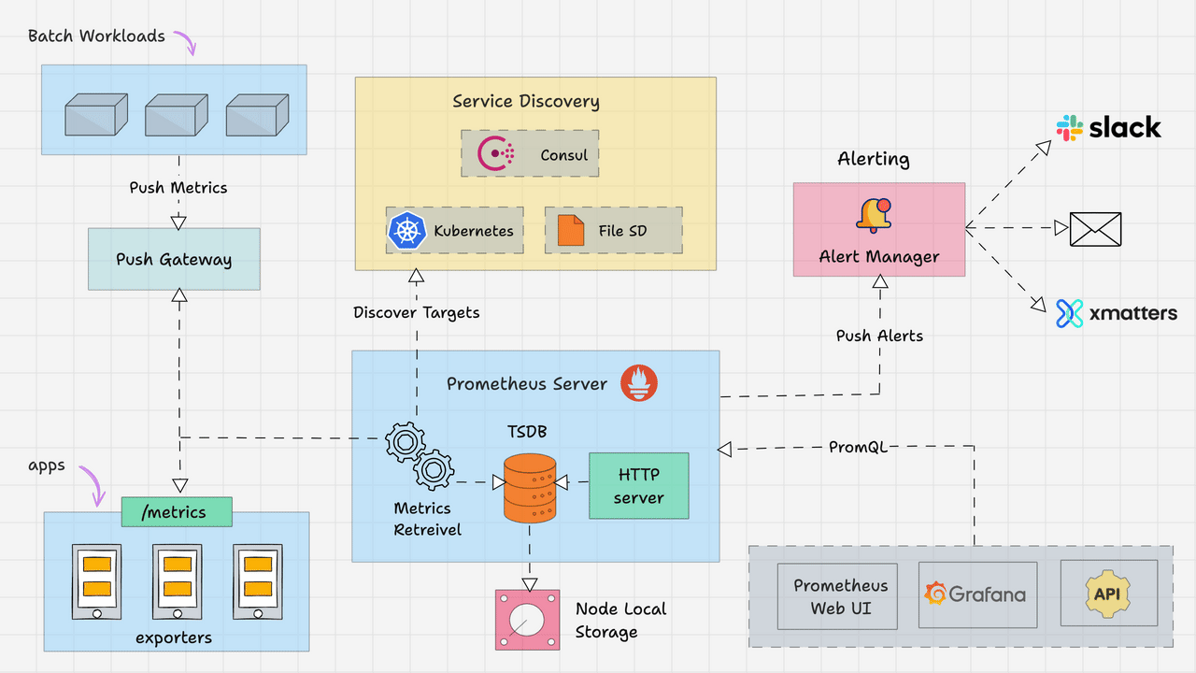

- PROMETHEUS ARCHITECTURE
- Prometheus is an open-source monitoring and alerting tool used to collect and store metrics (CPU, memory, requests, errors, etc.) from applications and servers.
- It mainly works on a Pull Model.

- Prometheus Architecture – Main Components
- Prometheus Server
- Central monitoring engine
- Scrapes metrics from targets using HTTP (pull model)
- Stores data in Time Series Database (TSDB)
- Executes PromQL queries
- Evaluates alert rules

- Targets
- Applications, servers, containers, or services being monitored
- Expose metrics via /metrics HTTP endpoint
- Provide metrics in Prometheus text format

- Exporters
- Agents that collect system or third-party metrics
- Convert metrics into Prometheus format
- Example: Node Exporter (server metrics), DB Exporter

- TSDB (Time Series Database)
- Built-in storage inside Prometheus
- Stores metrics as time-stamped key-value pairs
- Uses WAL (Write-Ahead Log) and data blocks

- Alertmanager
- Handles alerts generated by Prometheus
- Groups, silences, and routes alerts
- Sends notifications (Email, Slack, etc.)

- Service Discovery
- Automatically discovers dynamic targets
- Common in cloud and Kubernetes environments

- Grafana (Visualization Tool)
- Used to create dashboards
- Connects to Prometheus as data source

- 🔄 Prometheus Workflow (Step-by-Step)

[Application / Server]
│
│ (Expose /metrics endpoint)
▼
[Exporter]
│
│ (HTTP Pull)
▼
[Prometheus Server]
│
├── Stores data in TSDB
├── Runs PromQL Queries
└── Sends Alerts
│
▼
[Alertmanager]
│
▼
Email / Slack

- Simple :
Prometheus scrapes metrics from targets, stores them in a time-series database, evaluates rules, and sends alerts via Alertmanager while Grafana visualizes the data.

- PROMETHEUS INTERNAL ARCHITECTURE
- Prometheus internally scrapes metrics, writes them to WAL, stores recent data in memory (Head), persists them as time-series blocks on disk, and processes queries and alert rules using its built-in query engine.

- Components :
- Scrape Manager :
- Manages all configured targets
- Sends HTTP requests to /metrics endpoints
- Collects metrics at defined scrape intervals
- Works on Pull Model

- Service Discovery Manager
- Dynamically discovers targets
- Supports cloud & Kubernetes environments
- Updates target list automatically

- TSDB (Time Series Database Engine)
- Prometheus has a built-in TSDB.
- It stores data as : metric_name{label="value"} timestamp value
- Example : cpu_usage{instance="server1"} 1709000000 75
- Each metric = Time Series

- WAL (Write-Ahead Log)
- First writes incoming data to WAL
- Prevents data loss during crash
- Helps in recovery
- Data Flow : Scraped Data → WAL → Memory → Disk Blocks

- Head Block (In-Memory Storage)
- Recent data stored in memory
- Fast read & write
- Later compacted into persistent blocks

- Block Storage (Persistent Storage)
- Data stored in 2-hour blocks (default)
- Each block contains : Chunks (actual metric data)
  - Index (for fast search)
  - Metadata

- Compaction Process
- Merges small blocks into larger blocks
- Improves storage efficiency
- Reduces disk usage

- Query Engine
- Executes PromQL queries
- Reads data from : Head block, Persistent blocks
- Returns results via HTTP API

- Rule Engine
- Evaluates : Recording Rules, Alerting Rules
- Runs at configured intervals

- HTTP Server
- Provides : Web UI
- API access
- /metrics endpoint (self-metrics)

- Internal Data Workflow
Target → Scrape Manager
↓
WAL
↓
Head (Memory)
↓
Persistent Blocks
↓
Query Engine
↓
Web UI / API / Alerts

- PROMETHEUS MONITORING TOOL PRACTICAL
- Prometheus monitoring tool practical step by step
Commands :

Optional part for creating directory/ folder and for downloading but it gives clarity for avoiding confusion
Step1 : For creating a directory : mkdir downloads/
Step2 : For moving to directory : cd downloads/

Mandatory from here
Step3 : For getting link : wget https://github.com/prometheus/prometheus/releases/download/v3.10.0/prometheus-3.10.0.linux-amd64.tar.gz

Check : Click on link working or not
If working well and good else replace link with latest version

Step4 : For coming back one folder (if downloads created ): cd ..
Step5 : For extracting : tar -xvf ./downloads/prometheus-3.10.0.linux-amd64.tar.gz
Press tab for full name automatic

Step6 : For listing : ls
Step7 : For changing name : mv prometheus-3.10.0.linux-amd64/ prometheus

Step8 : For moving to Prometheus directory : cd prometheus/
Step9 : For listing : ls

Step 10 : For executing Prometheus 1: ./prometheus
For executing Prometheus in background 2 : ./prometheus &
For executing prometheus background 3 : nohup ./prometheus > prometheus.log2>&1 &
1 executes but if exited process stops
2 and 3 executes in background so we can exit safe

Now in text it shows starting server
Starting tsdb
Starting rule manager
Go language
Port 9090

For web view : <ipaddress>:9090

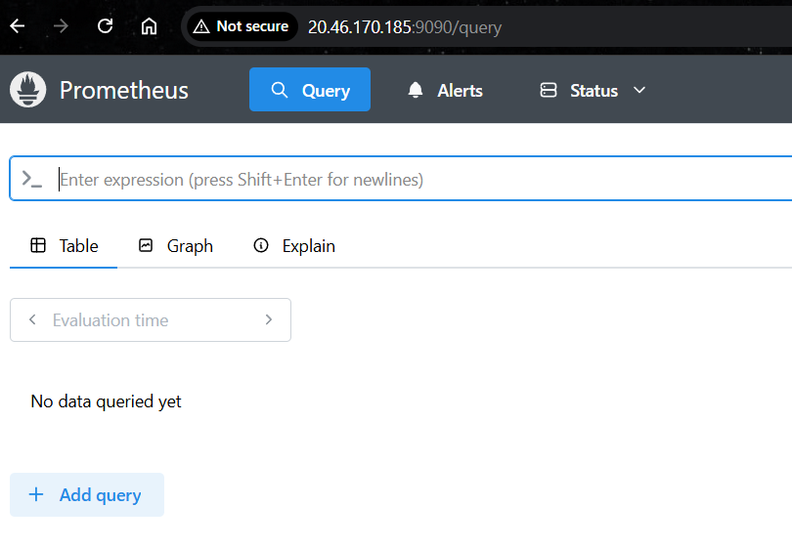

For checking Prometheus details and go language version
We can select option beside Prometheus select status and runtime & build information

Version : 3.10.0
Go Version : 1.26.0

Step 11 used when you use 1 and 2 : For stoping : ctrl + c
Step 12 : For checking port : pgrep Prometheus
You will get process ID
Step 13 : For stoping prometheus completely : kill <processID>
Done ok else use : kill -9 <processID>

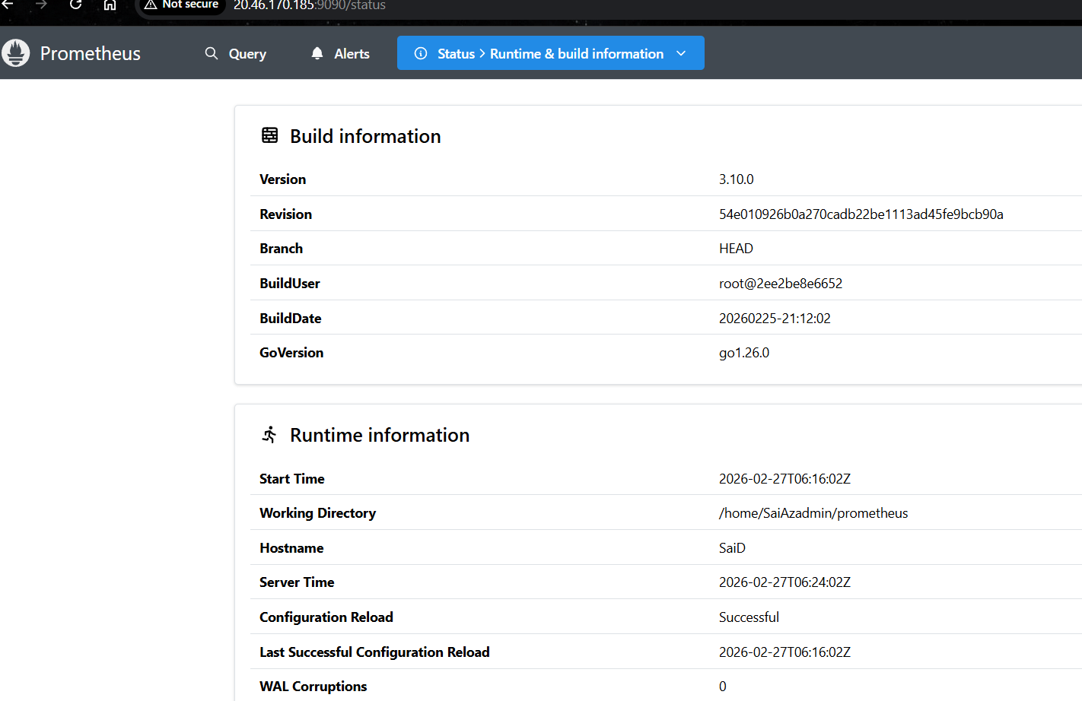

- PROMETHEUS NODE EXPORTER

- Prometheus Node Exporter is an exporter that collects hardware and OS-level metrics from a Linux/Unix system and exposes them in Prometheus format.
- It does NOT monitor applications
- It monitors the host (server / VM / node)

- Why Node Exporter Is Used : Node Exporter is used to monitor server health and performance.
- It provides visibility into : CPU usage, Memory usage, Disk usage, Network traffic, Load average
File system stats, Hardware info
- Without Node Exporter : Prometheus cannot see OS-level metrics

- What Metrics Does Node Exporter Provide :
- Some common metrics are :-
  - 🖥️ CPU : node_cpu_seconds_total
  - 🧠 Memory : node_memory_MemAvailable_bytes
  - 💾 Disk : node_filesystem_avail_bytes
  - 🌐 Network : node_network_receive_bytes_total
  - ⚙️ System Load : node_load1
node_load5
node_load15

- How Node Exporter Works :-
- Runs as a service or container on the server
- Collects metrics from : /proc, /sys
- Exposes metrics on : http://<node-ip>:9100/metrics
- Prometheus scrapes this endpoint

- Simple Architecture
Server / VM
└── Node Exporter (port 9100)
└── /metrics
↑
Prometheus Server (pull)

- Node Exporter vs Application Monitoring
Node Exporter | App Metrics
OS-level | App-level
CPU, RAM, Disk | Requests, latency
One per node | One per app

- “Prometheus Node Exporter is an agent that runs on a host to expose system-level metrics such as CPU, memory, disk, and network usage for monitoring.”

- PROMETHEUS NODE EXPORTER
- Node Exporter is an open-source metrics exporter for Linux/Unix systems that collects system-level hardware and operating system metrics and exposes them through an HTTP endpoint (/metrics) so monitoring systems like Prometheus can scrape them.

- Node Exporter is a Prometheus exporter that gathers host-level metrics from the Linux kernel and system resources and exposes them in Prometheus format for monitoring.

- Gather all the data and transform into Prometheus format
- Prometheus server will retrieve data
- Retrieval server will scrap the data and it will pull the data to Prometheus server
- Time series database will store
- http end points are used to trigger data and web ui will be used to get data

- Uses of Node Exporter : Node Exporter is used for infrastructure monitoring.
- Main Reasons
    - System Monitoring : Collects CPU, memory, disk, and network statistics.
    - Prometheus Integration : Provides metrics in a format that Prometheus can scrape.
    - Infrastructure Observability : Helps DevOps teams monitor servers, VMs, and cloud instances.
    - Visualization in Dashboards : Metrics can be visualized using Grafana dashboards.
    - Alerting : Metrics can trigger alerts through Prometheus and Alertmanager.

- How Node Exporter Works
Server (Linux Machine)
│
▼
Node Exporter (collects system metrics)
│
▼
Prometheus (scrapes /metrics endpoint)
│
▼
Grafana (visualizes dashboards)

- Interview point :
Node Exporter is a Prometheus exporter that collects system-level metrics such as CPU, memory, disk, and network usage from a host and exposes them via an HTTP endpoint for Prometheus to scrape and monitor infrastructure performance.

- PROMETHEUS NODE EXPORTER PRACTICAL
- Steps for installing
- Download node exporter or target machine
- Extract tar file and start node exporter
- Check are publishing Node exporter will work on 9100

- What monitor we need, depends on monitor requirement we use monitor node exporter
- We can check and downloads node exporter from : https://prometheus.io/docs/instrumenting/exporters/
- Depends on node we need

Open Prometheus.io website
Downloads -> for os
Optional part ( Create a folder downloads
Use command : wget and download Prometheus using web link )

Step1 : Create folder or directory : mkdir downloads
Step2 : Move to downloads : cd downloads/
Step3 : For downloading : wget https://github.com/prometheus/node_exporter/releases/download/v1.10.2/node_exporter-1.10.2.linux-amd64.tar.gz

Check this link opening or not
If working ok else replace it with new link

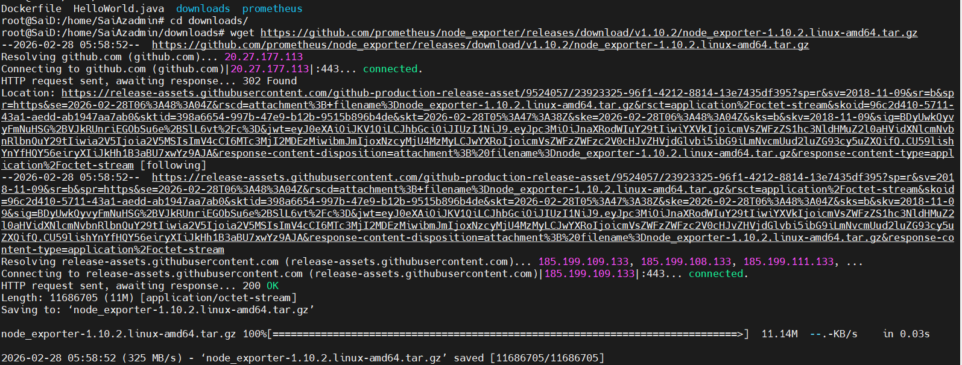

Step4 : For moving from downloads : cd ..
Step5 : For extracting node exporter : tar -xvf ./downloads/node_exporter-1.10.2.linux-amd64.tar.gz

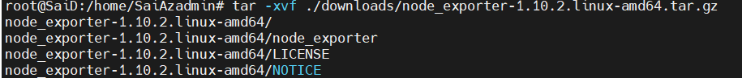

Step6 : Change folder name to node_exporter : mv node_exporter-1.10.2.linux-amd64/ node_exporter
Step 7 : Change folder to node exporter : cd node_exporter/
Step8 : For execution 1: ./node_exporter
For execution in background : ./node_exporter &
For execution in background : nohup ./node_exporter > node_exporter.log2>&1 &
For 1 we need to type ctrl + d for exiting but it stops
For 2 and 3 we need to type ctrl + d for exiting but it keeps running
Step 9 : For checking node exporter working or not
Step10 : Open web browser and type : <vm Pip>:9100

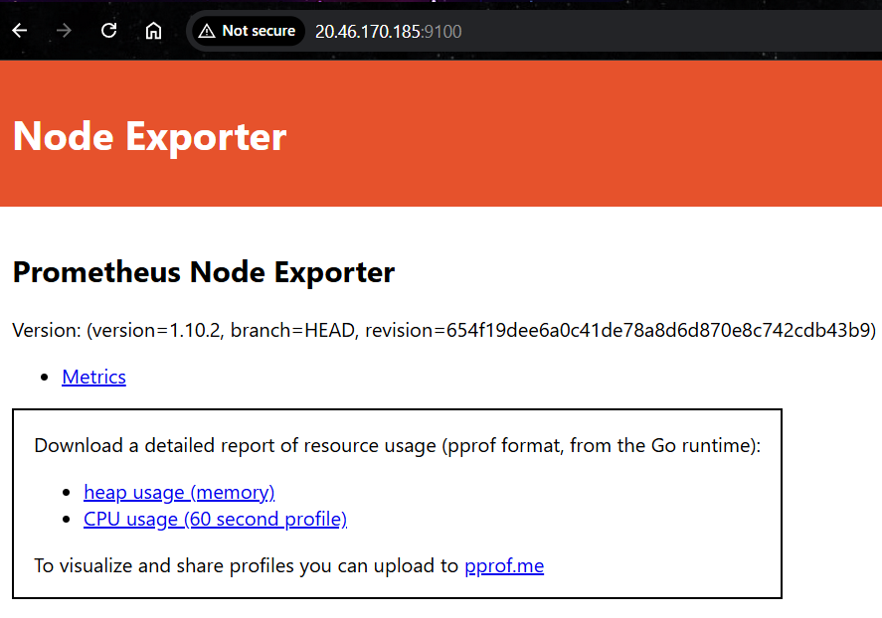

By executing node exporter we get in this way :

Now we need to write job here
For monitoring
Step 10 : Move back : cd ..
Step 11 : Move to prometheus folder : cd prometheus/
Step 12 : Now enter yaml file : vi prometheus.yml

Check this block :
- job_name: "prometheus"

# metrics_path defaults to '/metrics'
# scheme defaults to 'http'.

static_configs:
- targets: ["localhost:9090"]
# The label name is added as a label `label_name=<label_value>` to any timeseries scraped from this config.
labels:
app: "prometheus"

- Copy paste it again and edit as : change job name and app name as
  - prometheus to node_exporter
  - 9090 to 9100

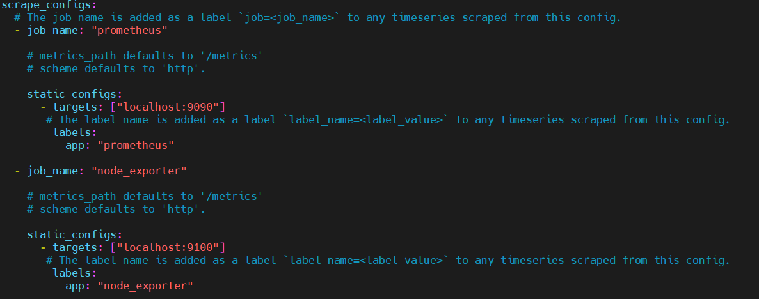

Now restart prometheus server
Check prometheus server :
Step13 : For checking : pgrep prometheus
Step 14 : For stoping : kill <service number>
Step 15 : For restarting : ./prometheus &

Check in web : <ip address>:9090
Now check status : health

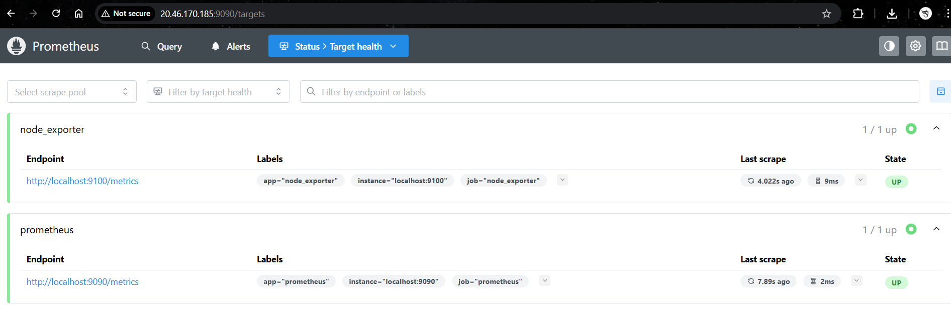

For node memory query :

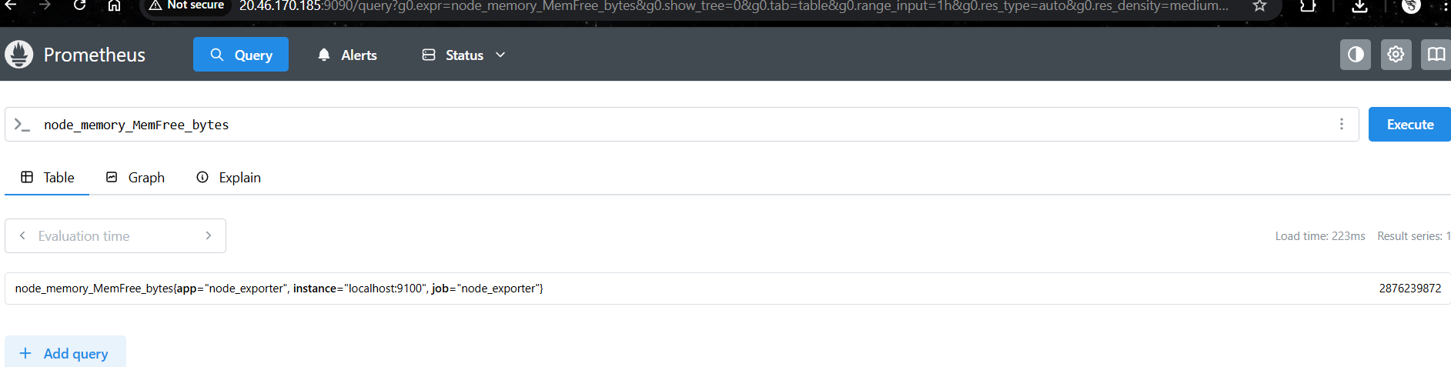

We can add and search multiple queries

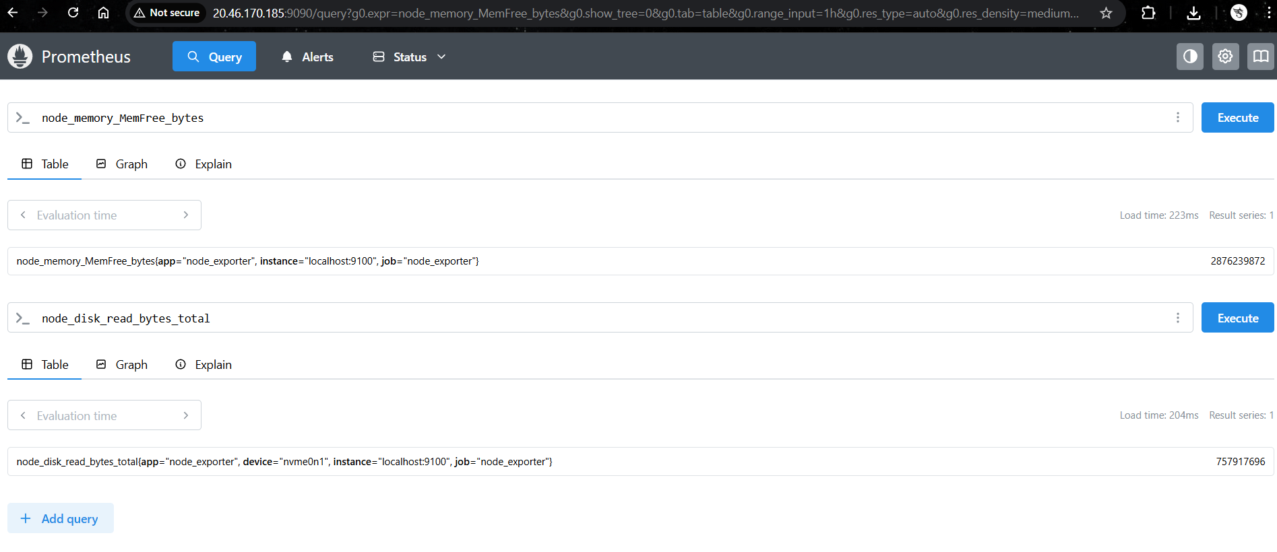

- PROMETHEUS ALERT MANAGER
- Alert manager is a centralized alert processing system that manages, groups, routes, and sends alerts generated by Prometheus monitoring rules.

Or

- Alertmanager is a Prometheus component responsible for handling alerts generated by Prometheus.
- It receives alerts, processes them, and sends notifications to configured receivers such as email, Slack, or PagerDuty.

- How Alert manager Works
- Node Exporter → Prometheus → Alertmanager → Notification (Email / Slack / etc.)

- Metrics are collected from exporters.
- Prometheus evaluates alert rules.
- When a condition is met, Prometheus fires an alert.
- The alert is sent to Alertmanager.
- Alertmanager processes and sends notifications.

- Why Alertmanager is Important
    - Alert Routing : Alertmanager sends alerts to different teams or channels based on labels.
    - Alert Grouping : Multiple alerts are combined into one notification to reduce alert noise.
    - Deduplication : Prevents sending duplicate alerts repeatedly.
    - Silencing Alerts : Temporarily mute alerts during maintenance windows.
    - Alert Inhibition : Suppresses lower-priority alerts when a higher-priority alert exists.

Main Functions of Alertmanager
Feature | Description
Grouping | Combines multiple similar alerts into one notification
Deduplication | Prevents duplicate alerts
Routing | Sends alerts to different receivers based on labels
Silencing | Temporarily suppresses alerts
Inhibition | Stops lower-priority alerts when a higher-priority alert is active

- Interview point : Alertmanager is a Prometheus component that handles alerts by performing alert grouping, deduplication, routing, silencing, and sending notifications to external systems such as email or Slack.

- PROMETHEUS ALERT MANAGER PRACTICAL
- Prometheus alerting rules
- Alerting rules define you alerting conditions,
- Based on conditions it will send alert or inform
- If alert trigger it will send alert manager, it manager will send notify

In yaml files we write jobs to scan and get status

For getting alert we write rules
In yaml we write rules, using this yaml it will send alert to alert manager it will send to outside

Step 1 : In prometheus.yml file ( remove # symbol to activate it )
rule_files:
- “first_rules.yml”
- “second_rules.yml”

Step2 : In first_alert.yml file
Sample one with simple : whether system is up or running or not
groups:
- name: node_alert
rules:
alert: node_exporter_status
expr: up{job=”node_exporter"} == 0

Sample rule 2 with extended mentioned present
groups:
- name: node_alert
rules:
# Node Exporter Status
- alert: node_exporter_status
expr: up{job="node_exporter"} == 0
for: 1m
labels:
severity: critical
annotations:
summary: "Node Exporter Down"
description: "Node exporter is not running on {{ $labels.instance }}"

# High CPU Usage
- alert: high_cpu_usage
expr: 100 - (avg by(instance)(rate(node_cpu_seconds_total{mode="idle"}[5m])) * 100) > 80
for: 2m
labels:
severity: warning
annotations:
summary: "High CPU Usage"
description: "CPU usage is above 80% on {{ $labels.instance }}"

# High Memory Usage
- alert: high_memory_usage
expr: (1 - (node_memory_MemAvailable_bytes / node_memory_MemTotal_bytes)) * 100 > 80
for: 2m
labels:
severity: warning
annotations:
summary: "High Memory Usage"
description: "Memory usage is above 80% on {{ $labels.instance }}"

# Low Disk Space
- alert: disk_space_low
expr: (node_filesystem_avail_bytes{mountpoint="/"} / node_filesystem_size_bytes{mountpoint="/"}) * 100 < 20
for: 2m
labels:
severity: warning
annotations:
summary: "Low Disk Space"
description: "Disk space less than 20% available on {{ $labels.instance }}"

Step3 : After writing rules
Restart prometheus and node server
Observe this in alerts
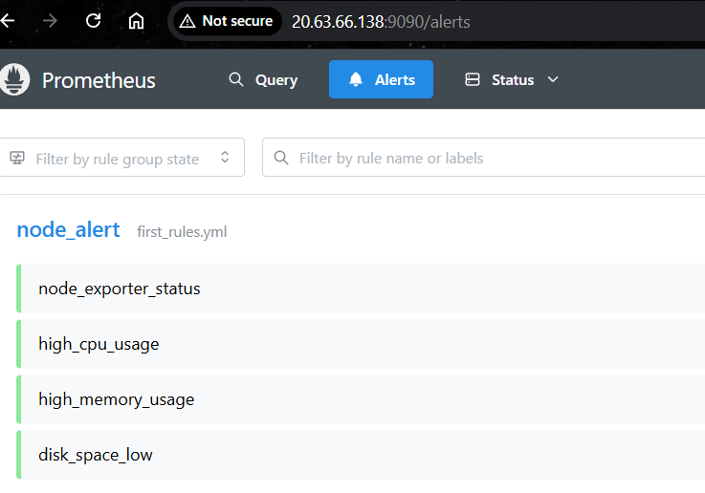

Step4 : in prometheus.yml file ( we can change time interval based on we need )
# my global config
global:
scrape_interval: 15s # Set the scrape interval to every 15 seconds. Default is every 1 minute.
evaluation_interval: 15s # Evaluate rules every 15 seconds. The default is every 1 minute. # scrape_timeout is set to the global default (10s). #Alertmanager configuration

alerting:
alertmanagers:
static_configs:
targets:
# alertmanager: 9093 .

#Load rules once and periodically evaluate them according to the global 'evaluation_interval'. rule files:
"first_rules.yml"
"second_rules.yml"

# A scrape configuration containing exactly one endpoint to scrape:
#Here it's Prometheus itself.

Step 5 : to check rules working correctly or not
Step6 : To check promtool version : promtool --version
Step 7 : To check working or not : ./promtool check rules first_rules.yml

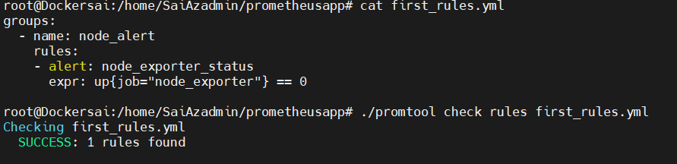

- Now for alert manager

Edit prometheus.yml file : vi prometheus.yml
Check alert manager name :
From : # - alertmanager:9093
To as it is local : - localhost:9093
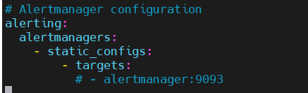

Modify it with
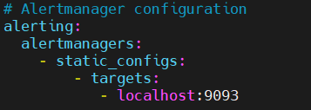

Prometheus alert manager website : https://prometheus.io/download/#alertmanager

For installing alert manager
Step 8 : Be in downloads folder : cd downloads/
Step 9 : For downloading file : wget https://github.com/prometheus/alertmanager/releases/download/v0.31.1/alertmanager-0.31.1.linux-amd64.tar.gz
Check on link is working or not
If no replace with latest link

Step 10 : For extracting file : tar -xzvf ./downloads/alertmanager-0.31.1.linux-amd64.tar.gz
Step 11 : For changing name : mv alertmanager-0.31.1.linux-amd64 alertmanager
Step 12 : For moving to alert folder : cd alertmanager/

Step 13 : restart prometheus, node exporter and alert manager
Step 14 : check service number : pgrep <service name>
Prometheus/node_exporter/alertmanager

Step 15 : Stop the services by killing it : kill <service number>
Again check : pgrep <service number>
If not found well and good
If found force stop it using : kill -9 <service number>

Step 16 : go to folder and start services
Go to prometheus folder from home : cd prometheus/
Start prometheus : ./prometheus &
Go to node exporter folder : cd node exporter/
Start node exporter : ./node_exporter &
Go to alert manager folder from home : cd alertmanager :
Start alert manager : nohup ./alertmanager > alertmanager.log 2>&1 &

For checking service number type : pgrep alertmanager

Now access in web using ip address and port access alert manager : <ipaddress>:9093

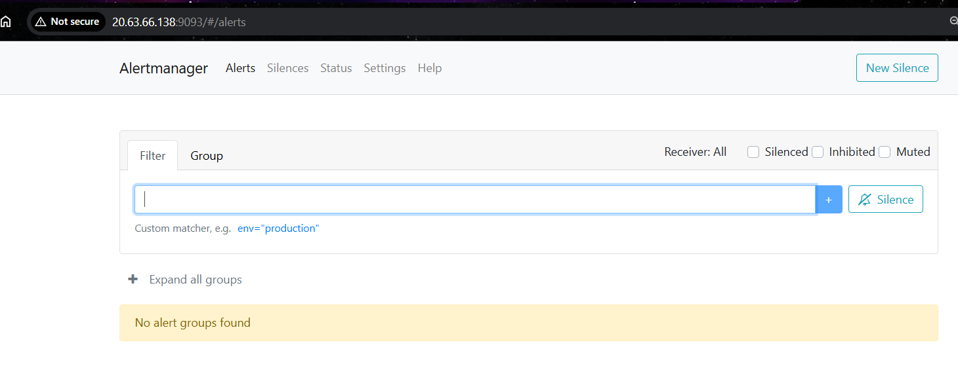

- GRAFANA VISUALIZATION TOOL
- Grafana is an open-source monitoring and visualization platform used to query, analyze, and display metrics from different data sources in dashboards.

Or

- Grafana is a data visualization and observability tool that connects to monitoring systems like Prometheus, queries their metrics, and displays them as graphs, charts, and dashboards.

- How Grafana Works
- Node Exporter → Prometheus → Grafana Dashboard

- Exporters collect system metrics (CPU, memory, disk).
- Prometheus stores these metrics.
- Grafana queries Prometheus.
- Grafana displays metrics as visual dashboards.

- Main Features of Grafana
Feature | Description
Dashboards | Visual panels for monitoring metrics
Data Source Integration | Connects to Prometheus, Elasticsearch, MySQL, etc.
Visualization | Graphs, gauges, tables, heatmaps
Alerting | Can trigger alerts based on thresholds
Real-time Monitoring | Displays live infrastructure metrics

- Interview point :
Grafana is an open-source visualization and monitoring tool used to create dashboards and analyze metrics collected from data sources like Prometheus.

- GRAFANA VISUALIZATION TOOL PRACTICAL

Official Grafana website : Grafana.com
Download from : https://grafana.com/grafana/download?pg=get&plcmt=selfmanaged-box1-cta1
Choose version from it
Select edition as OSS not enterprise

Installing method 1 :
sudo apt-get install -y adduser libfontconfig1 musl
wget https://dl.grafana.com/grafana/release/12.4.0/grafana_12.4.0_22325204712_linux_amd64.deb
sudo dpkg -i grafana_12.4.0_22325204712_linux_amd64.deb

Installing method 2 :
Add Grafana repository
sudo apt-get install -y apt-transport-https software-properties-common wget
wget -q -O - https://packages.grafana.com/gpg.key | sudo apt-key add -
echo "deb https://packages.grafana.com/oss/deb stable main" | sudo tee /etc/apt/sources.list.d/grafa

Update packages : sudo apt update
Install Grafana : sudo apt install grafana -y

Steps to start Grafana :
Step 1 : Start Grafana Service : sudo systemctl start grafana-server
Step 2 : Enable auto start : sudo systemctl enable grafana-server
Check status : sudo systemctl status grafana-server
Grafana runs on port 3000 by default.

It asks username and password
Username = admin
Password = admin

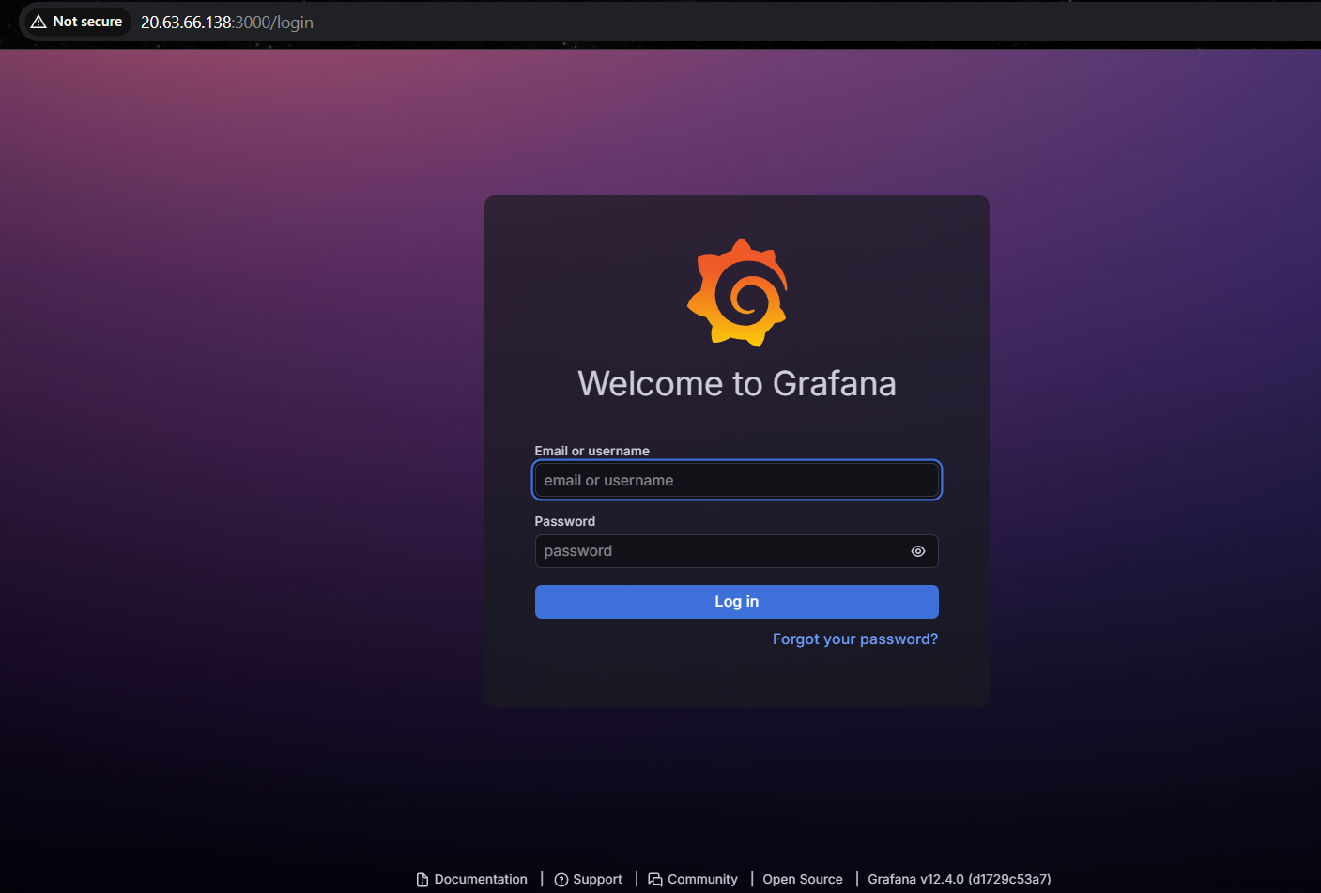

Change password you like else leave it

After login

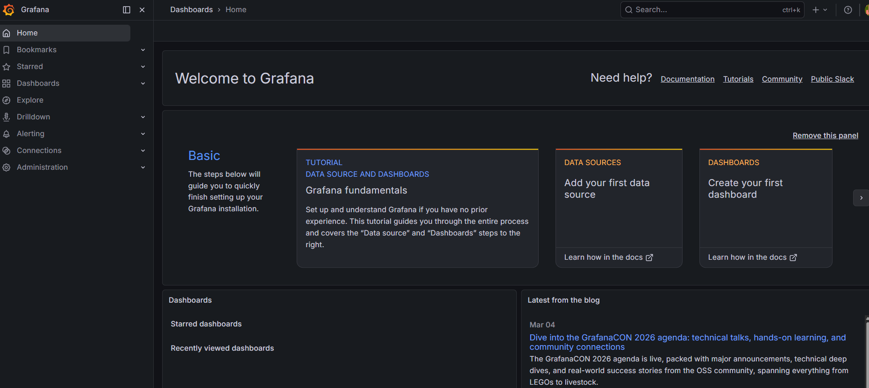

Left bar
In left side you can find home click on it

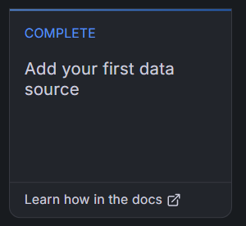

Check add your data source and click on it
In add data source you can find many tools as Grafana supports many tools
Click on prometheus

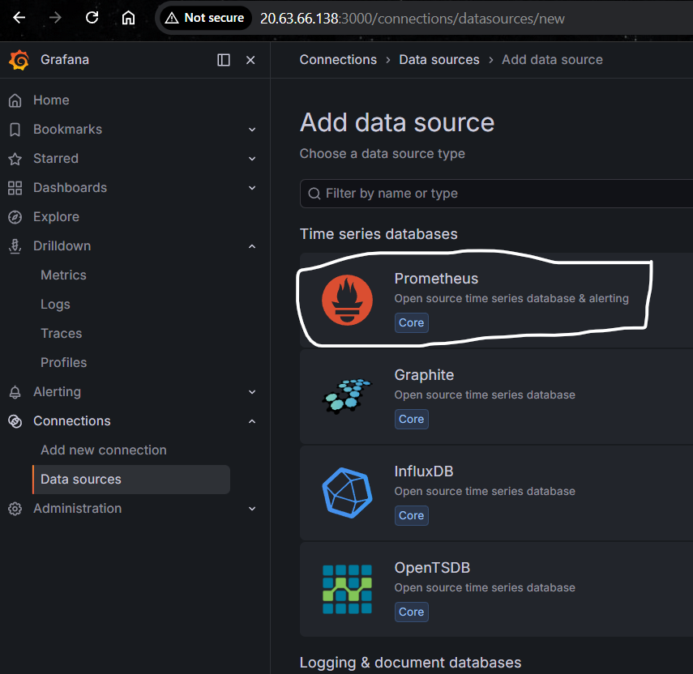

Enter prometheus server ip address with port attach/
Ex : http://20.63.66.138:9090/

You will get this


If error occurs rectify it

- After that

Click on explore view
You can get this view
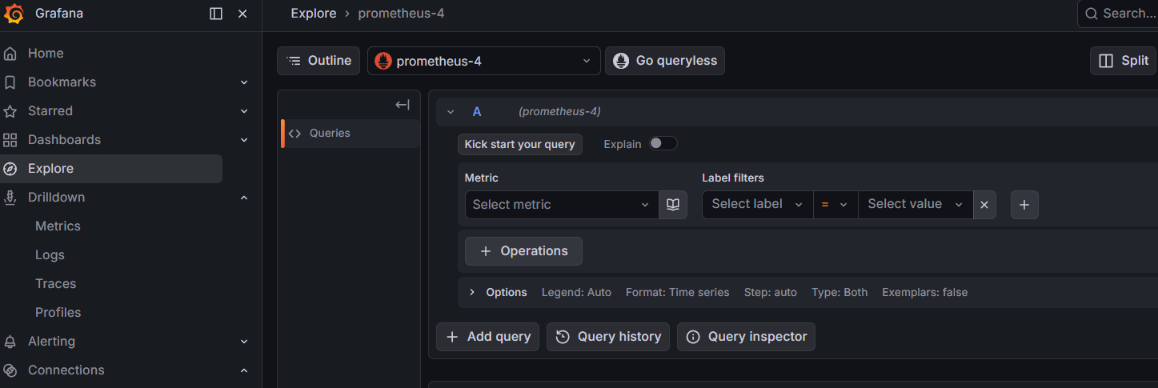

In metric type any metric name and click on run query
Else click on rotate

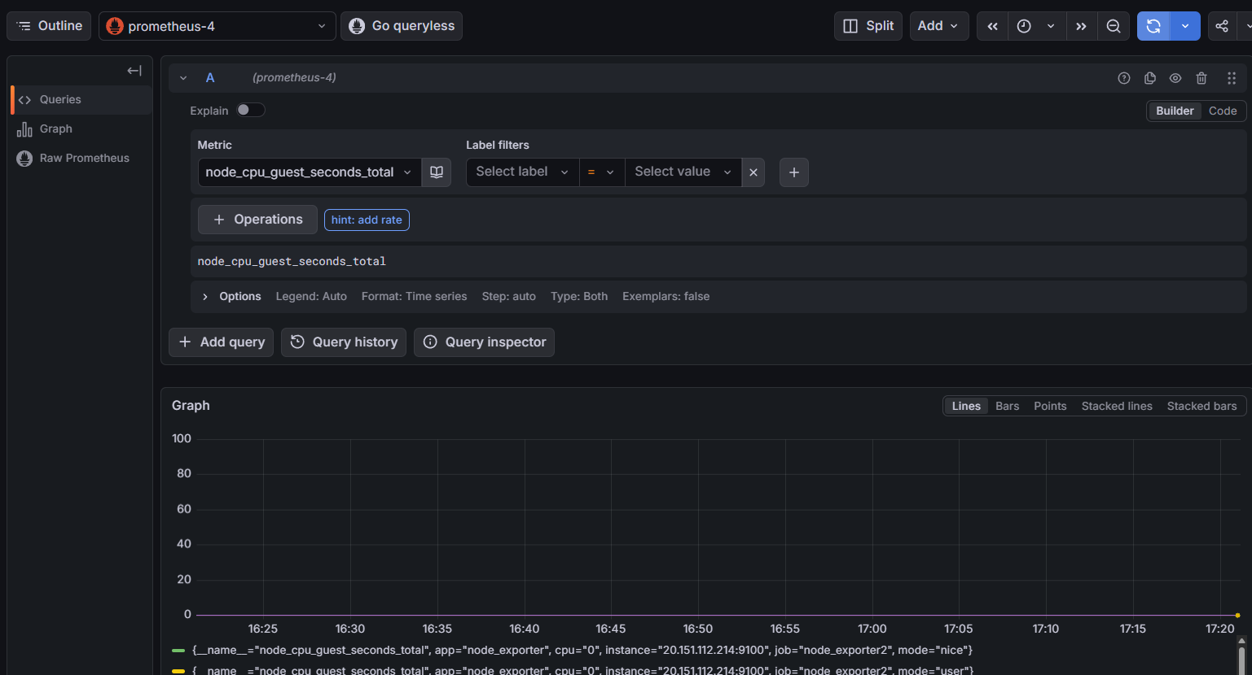

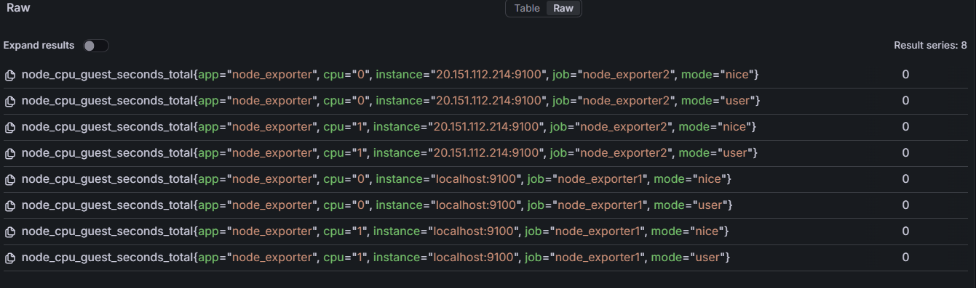

We can put multiple queries

- Now we need dashboard

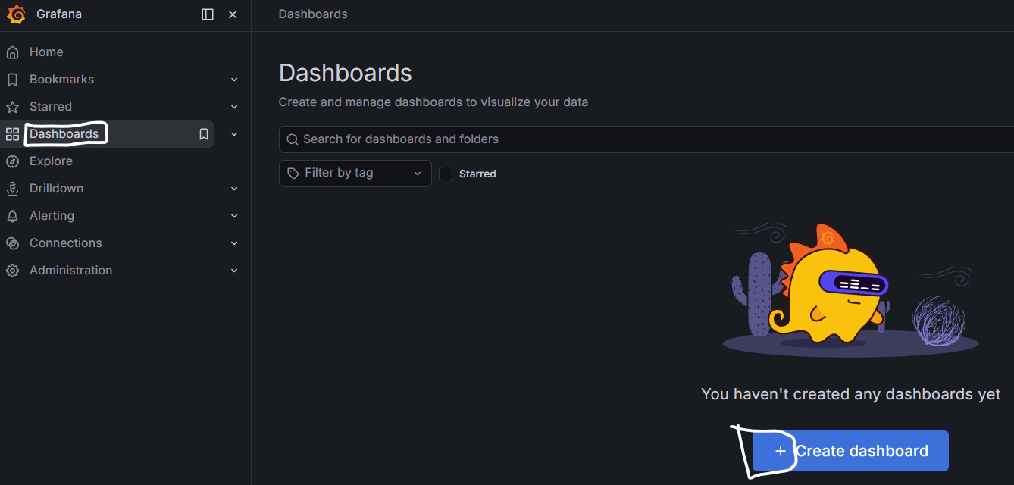

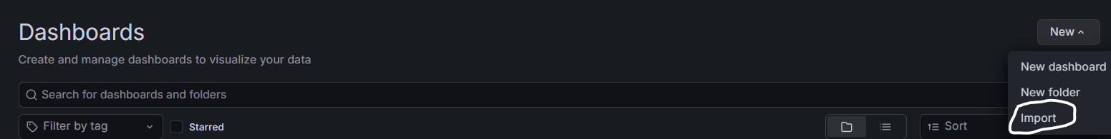

From Grafana server dashboard link : https://grafana.com/grafana/dashboards/

Search any dash boards related to Prometheus → Node Exporter → Grafana

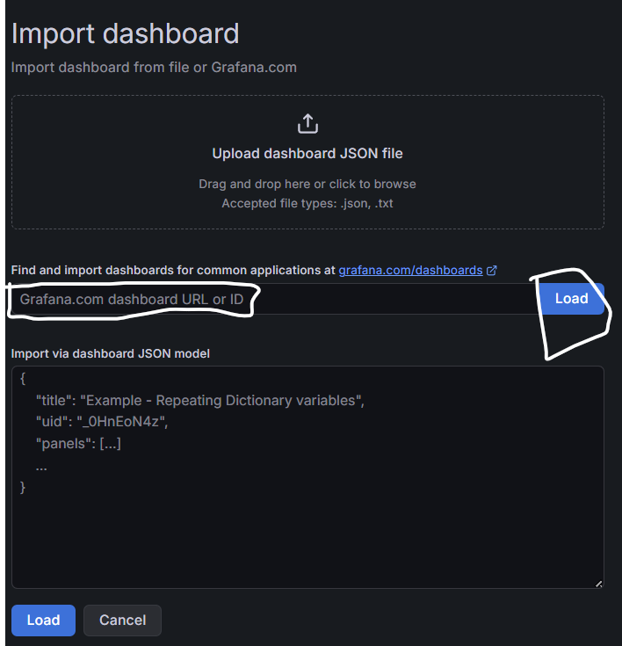

Click on load

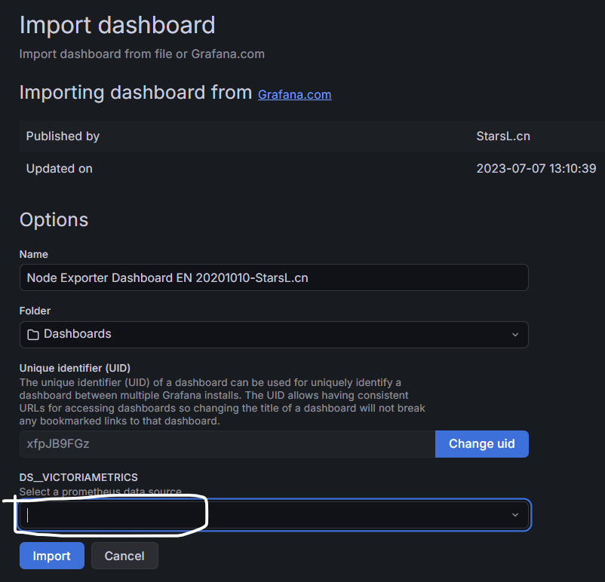

At ds_victoriametrics : Select prometheus 1 and import

Change data source and job to check it
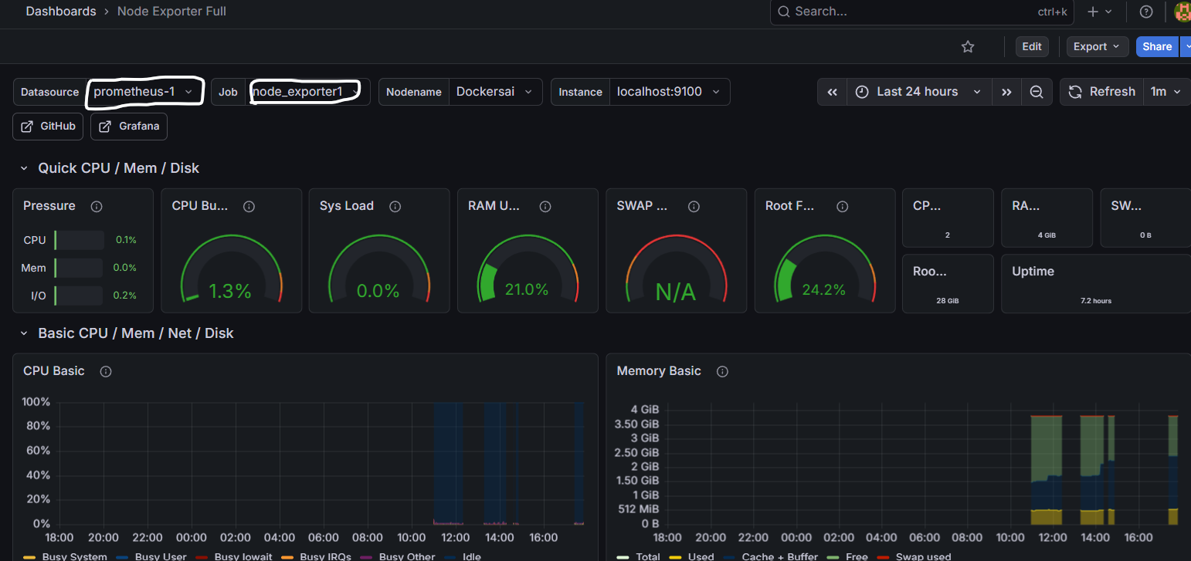

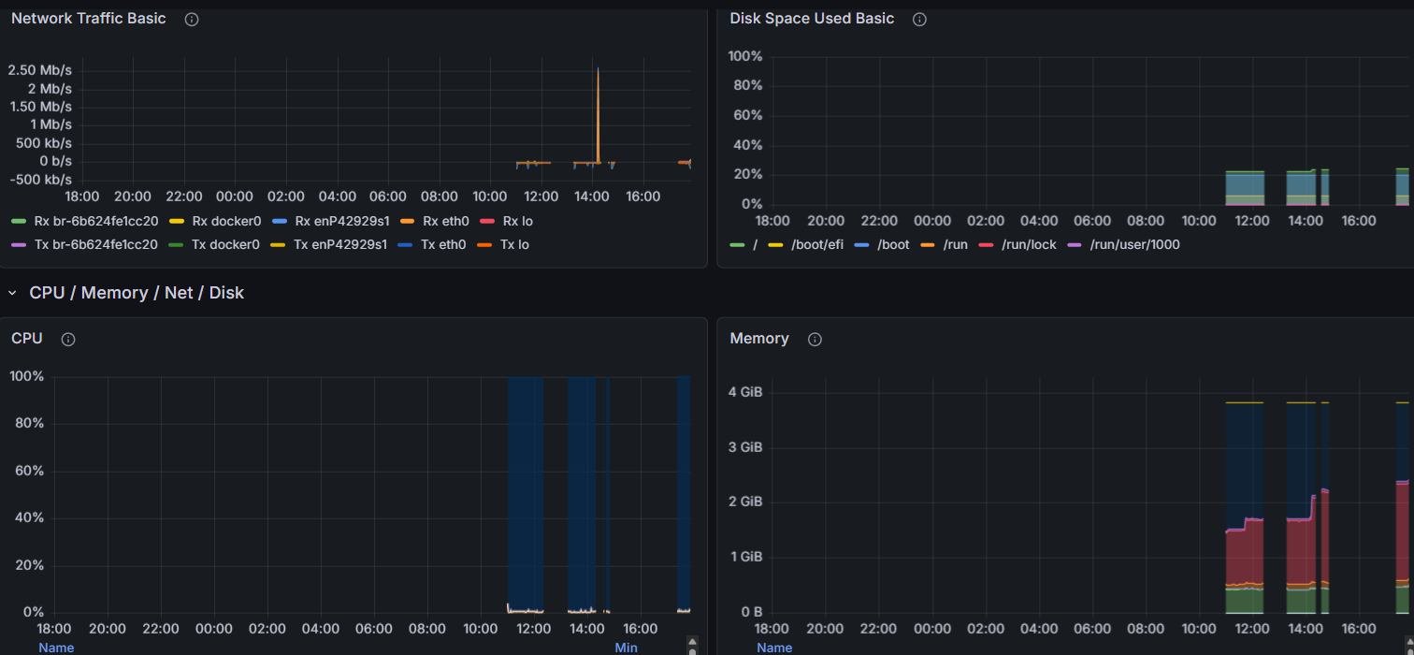

Under administration -> general -> settings
Under connections -> add new connection ->
Top right you can find add new data source

Find this block :
Connection : Prometheus server URL * : http://20.63.66.138:9090
Enter your prometheus address : <ipaddress>:9090

Click on save and test
